UNITED STATES
SECURITIES AND EXCHANGE COMMISSION
Washington, D.C. 20549

SCHEDULE 14A

Proxy Statement Pursuant to Section 14(a) of
the Securities Exchange Act of 1934 (Amendment No. )

Filed by the Registrant ☐

Filed by a Party other than the Registrant ☐

Check the appropriate box:
☐ | Preliminary Proxy Statement
☐ | Confidential, for Use of the Commission Only (as permitted by Rule 14a-6(e)(2))
☐ | Definitive Proxy Statement
☒ | Definitive Additional Materials
☐ | Soliciting Material under §240.14a-12

VORNADO REALTY TRUST

(Name of Registrant as Specified in Its Charter)

(Name of Person(s) Filing Proxy Statement, if other than the Registrant)

Payment of Filing Fee (Check the appropriate box):
☒ | No fee required.
☐ | Fee paid previously with preliminary materials.
☐ | Fee computed on table in exhibit required by Item 25(b) per Exchange Act Rules 14a6(i)(1) and 0-11.

 |  | Your Vote Counts! Smartphone users Point your camera here and vote without entering a control number For complete information and to vote, visit www.ProxyVote.com Control # V88842-P46891 *Please check the meeting materials for any special requirements for meeting attendance. VORNADO REALTY TRUST 888 SEVENTH AVENUE NEW YORK, NY 10019 VORNADO REALTY TRUST 2026 Annual Meeting Vote by May 20, 2026 11:59 PM ET You invested in VORNADO REALTY TRUST and it’s time to vote! You have the right to vote on proposals being presented at the Annual Meeting. This is an important notice regarding the availability of proxy materials for the shareholder meeting to be held on May 21, 2026. Get informed before you vote View the Notice and Proxy Statement and Annual Report online OR you can receive a free paper or email copy of the material(s) by requesting prior to May 7, 2026. If you would like to request a copy of the material(s) for this and/or future shareholder meetings, you may (1) visit www.ProxyVote.com, (2) call 1-800-579-1639 or (3) send an email to sendmaterial@proxyvote.com. If sending an email, please include your control number (indicated below) in the subject line. Unless requested, you will not otherwise receive a paper or email copy. Vote Virtually at the Meeting* May 21, 2026 11:30 A.M., New York Time Virtually at: www.virtualshareholdermeeting.com/VNO2026
 | 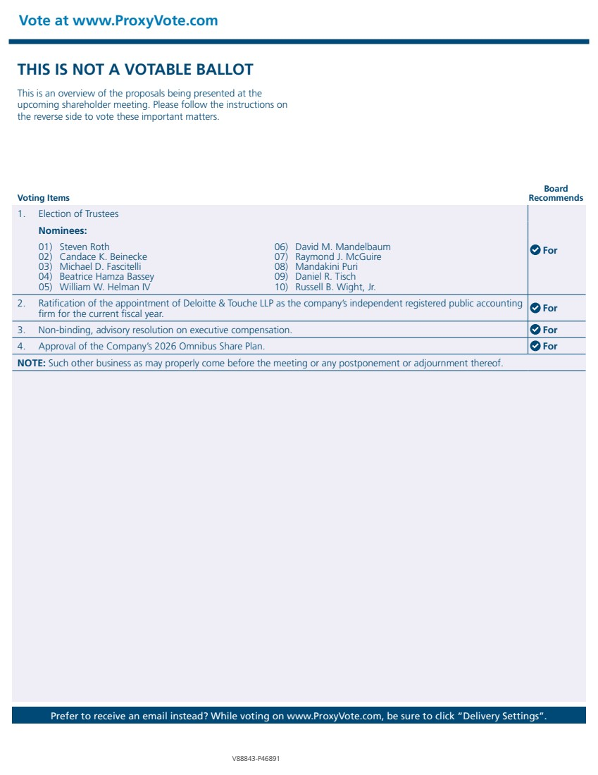 | Vote at www.ProxyVote.com Prefer to receive an email instead? While voting on www.ProxyVote.com, be sure to click “Delivery Settings”. Voting Items Board Recommends V88843-P46891 THIS IS NOT A VOTABLE BALLOT This is an overview of the proposals being presented at the upcoming shareholder meeting. Please follow the instructions on the reverse side to vote these important matters. 1. Election of Trustees For Nominees: 01) Steven Roth 02) Candace K. Beinecke 03) Michael D. Fascitelli 04) Beatrice Hamza Bassey 05) William W. Helman IV 06) David M. Mandelbaum 07) Raymond J. McGuire 08) Mandakini Puri 09) Daniel R. Tisch 10) Russell B. Wight, Jr. 2. Ratification of the appointment of Deloitte & Touche LLP as the company’s independent registered public accounting firm for the current fiscal year. For 3. Non-binding, advisory resolution on executive compensation. For 4. Approval of the Company’s 2026 Omnibus Share Plan. For NOTE: Such other business as may properly come before the meeting or any postponement or adjournment thereof.

